Part 1: Fuzzy Matching
Between 2010 and 2015, the number of wards in Tanzania went from 3,333 to 3,944. This happened by dividing existing ward into 2 (or in some cases three or more) new wards. You have to create a dataset where each row is a 2015 ward matched with the corresponding parent ward from 2010. It’s a trivial task to match wards that weren’t divided, but it’s impossible to match wards that were divided without additional information. Thankfully, we had access to shapefiles from 2012 and 2017. We used ArcGIS to create a new dataset that tells us the percentage area of 2015 ward that overlaps a 2010 ward. You can use information from this dataset to match wards that were divided. Can you generate the following insights:
- How many wards exist both in 2010 and 2015?
Answer: 2115 wards existed both in 2010 and 2015
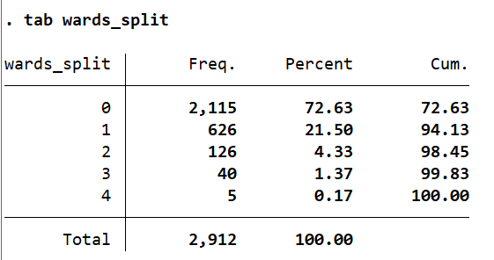
- How many are “parentless” wards (i.e. exist in 2015 but not in 2010)
Answer: 1120 wards existed only in 2015 but not in 2010
- How many are “childless” wards? (i.e. exist in 2010 but not in 2015)
Answer: 852 wards existed solely in 2010
- How many wards were divided into two wards between 2010 and 2015?
Answer: 626 wards were divided into two wards between 2010 and 2015
- How many wards were divided into three or more wards between 2010 and 2015?
Answer: 45 wards were divided into three or more wards between these years
- List regions along with the rate of ward division
Answer: The list is as follows:
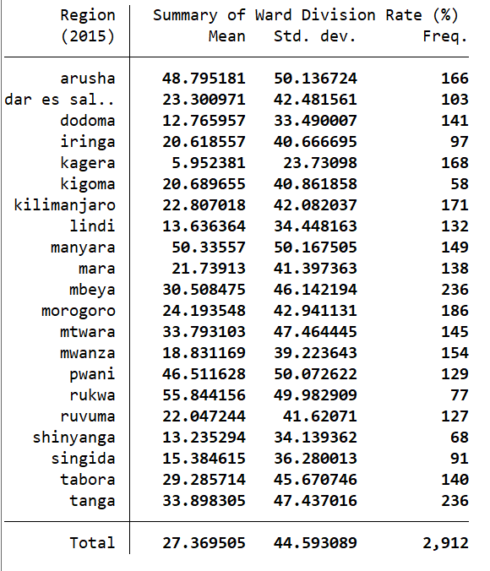
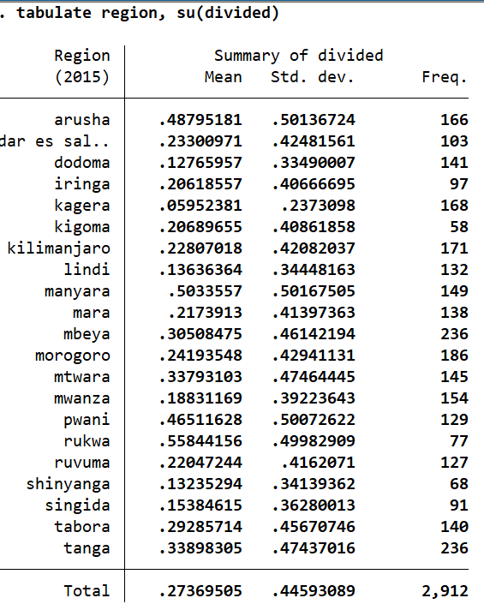
The average here tells us the proportion of divided regions in the dataset.
Part 2: De-biasing a parameter estimate using controls
- Develop some data generating process for data X’s and for outcome Y, with a treatment variable and treatment effect (0.3 sd)
- This DGP should include:
  - In addition to creating Y & treatment variables, also create confounder, mediator and a collider var (wrt Ys & treatment)
  - Each of these covariates should be clearly labelled (i.e. put a comment in the code next to where you generate each covariate explaining how it affects the generation of Y).
  - This process need not be complex, you could do everything with basic operations and uniformly distributed random values plus some dataset manipulation.
- Construct at least five different regression models with combinations of these covariates. (Type h fvvarlist for information on using fixed effects in regression.) Run these regressions at different sample sizes, using a program like last week. Collect as many regression runs as you think you need for each, and produce figures and tables comparing the biasedness and convergence of the models as N grows. Can you produce a figure showing the mean and variance of beta for different regression models, as a function of N? Can you visually compare these to the "true" parameter value?
Fully describe your results in a README file, including figures and tables as appropriate

Part 3: Spatial Analysis
Generate any choropleth map at region/state level, where you have to merge some publicly available data (e.g. population, average income, number of accidents etc.) with the shapefile before generating the choropleth map.
Hint: See slide 42 (https://www.stata.com/meeting/italy12/abstracts/materials/it12_pisati.pdf)
